Day 36 – 16:1 MUX Using 8:1 MUX

Introduction: A 16:1 MUX selects one of 16 inputs using 4 select lines.

Design
- Two 8:1 MUXes are used.
- S2, S1, S0 select inputs in the 8:1 MUXes.
- S3 selects between the two 8:1 MUX outputs.
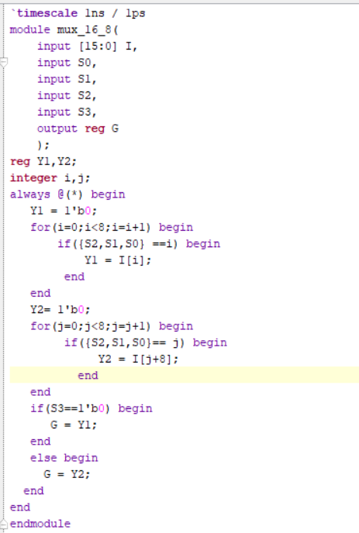

Waveform:

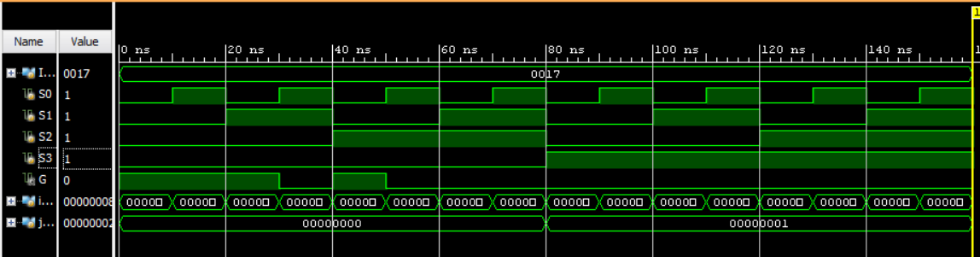

Schematic

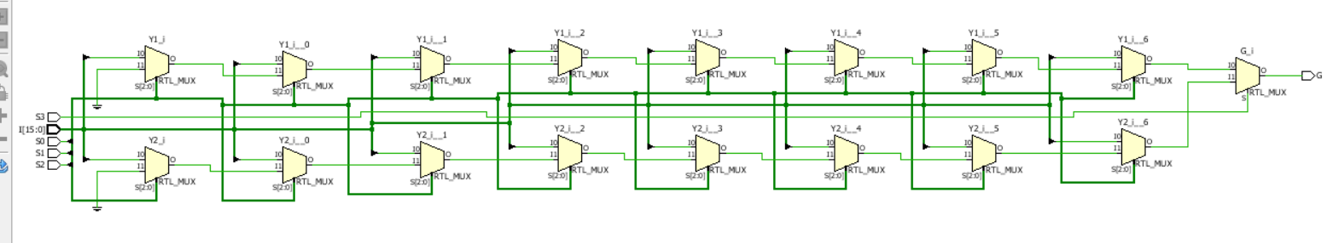

Testbenches:
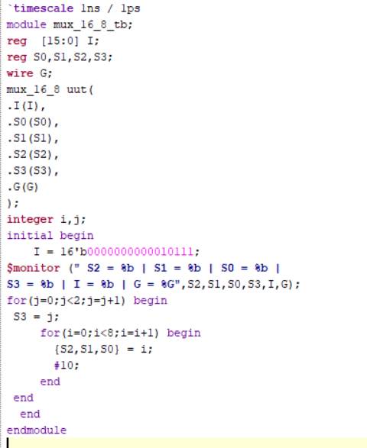

Observation:The output correctly selects one of the 16 inputs according to the select lines.

#PHANEENDRA.SINGUDASU

